A Learning Journey for High School & Middle School Students with Developmental Disabilities
June 19 – 24, 2016
Deadline to Apply: April 22, 2016
The Commonwealth Council for Developmental Disabilities (CCDD) is excited to announce a special opportunity for middle and high school students with developmental disabilities. We are offering scholarships for 15-20 Kentucky students to participate in a special experiential education and leadership development opportunity.

Close Up is a non-profit, non-partisan, civic education organization with a mission to “inform, inspire and empower youth to be actively engaged citizens in our democracy.” Close Up provides week-long educational opportunities for students to visit and learn in Washington, DC. For more information about Close Up, visit http://www.closeup.org/.

Close Up and CCDD are working together to provide this unique educational opportunity to Kentucky students with developmental disabilities.

During this educational, full immersion program, students will participate in:
- Small group workshops led by trained program instructors
- Seminars with DC journalists
- Question & Answer sessions with lobbyists
- Meetings with members of Congress and their staff
- The program itinerary is available online at http://www.closeup.org/lib/hs-washington-dc-schedule.pdf
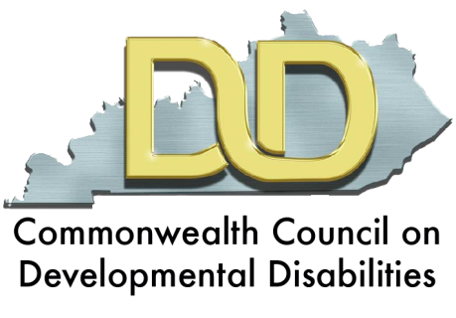
The CCDD will cover all lodging and travel expenses for participants. This will include meals, materials, all entrance fees, and 24 hour supervision (including night monitors). Scholarships will also cover costs for personal care attendant services, for those students who need such services.

Applicants will be notified by May 6, 2016 whether they were selected.
APPLICATION INSTRUCTIONS
- To qualify, you must be a person with a developmental disability (DD) who is enrolled in middle or high school in Kentucky.
“Developmental disability” means a severe, chronic disability of an individual that—
- is attributable to a mental or physical impairment or combination of mental and physical impairments;
- is manifested before the individual attains age 22;
- is likely to continue indefinitely;
- results in substantial functional limitations in 3 or more of the following areas of major life activity:
  - Self-care.
  - Receptive and expressive language.
  - Learning.
  - Mobility.
  - Self-direction.
  - Capacity for independent living.
  - Economic self-sufficiency; and
- reflects the individual’s need for a combination and sequence of special, interdisciplinary, or generic services, individualized supports, or other forms of assistance that are of lifelong or extended duration and are individually planned and coordinated.

- You can type or write your answers on this application. If you need more space, you can submit an additional page. If you need help filling out this application, or would like to submit your application in a different format, please contact Stephanie Adams at Stephanie.Adams@ky.gov or at 1-877-367-5332.
- Email or mail your completed application by April 22, 2016.
  - Using email: Setphanie.Adams@ky.gov with the subject line “2016 Close Up”
  - Using Postal Mail:
Commonwealth Council on Developmental Disabilities
32 Fountain Place
Frankfort, KY 40601
APPLICATION FORM

Name: __________

Address: _________________________________

City: State: Zip Code:

Phone: Email:

Do you have a developmental disability (as defined on page 2)? YES or NO
If yes, what is your disability? (optional)_________________________________________________

Where do you go to school? ______________________________ What is your current grade? ____

What is your gender? What is your age? _________

What group, if any, are you affiliated with? (such as The Arc or Best Buddies) __________________

What is your race/ethnicity? (optional)

Do you live in an urban or rural community? RURAL or URBAN

SHORT ANSWER SECTION
(Please use an additional sheet if necessary.)
- What are your goals for participating in this educational opportunity? How are you hoping the trip will impact your life moving forward?

- Do you think it is important that US Citizens visit Washington, DC? Why or why not?

- Discuss a current national issue that is important to you. Explain the issue and briefly represent arguments from two (2) different sides. Then, state your beliefs on the issue.

- All participants must develop a plan for using what they learn after they return home. Please briefly describe how you will use what you learn.

- What accommodations, if any, you will need to fully participate in this program?

I give my permission for my student to apply for this opportunity.

Signature of Parent or Guardian:________________________ Date: __________________

